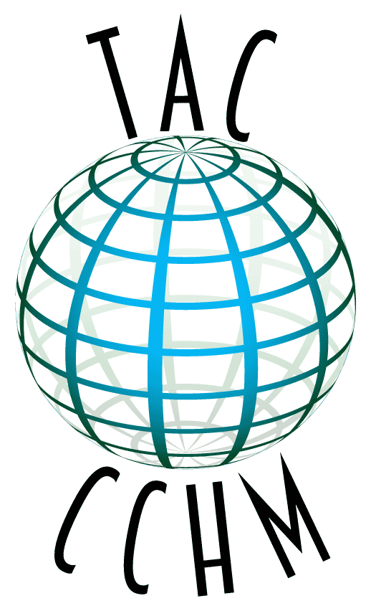

The Archaeology Channel
Conference on Cultural Heritage Media

Hilton Eugene and Conference Center

Eugene, Oregon, USA
11-15 May 2016
REGISTRATION FORM
ABOUT THE CONFERENCE
The Archaeology Channel Conference on Cultural Heritage Media, organized by Archaeological Legacy Institute, invites interested parties to gather for the discussion of audiovisual media for the study, preservation and promotion of cultural heritage. We wish to focus on topics of interest to cultural heritage professionals, media professionals and all those interested in applications of cultural heritage media.

Our goal is to create an unparalleled worldwide networking opportunity for cultural heritage filmmakers and others interested in the making and uses of cultural heritage media, including archaeologists, indigenous groups, musicians, artists, tourism operators, journalists, educators, historic preservation organizations, and others.

TAC Conference activities will include symposia, presentations, an exhibit hall, a banquet, and other events yet to be announced. TAC Conference is held in conjunction with the thirteenth annual edition of The Archaeology Channel International Film and Video Festival, a juried competition in the cultural heritage film genre.

All registered participants will receive complimentary Conference parking as well as tickets to TAC Festival film screenings that will take place May 12-15, 2016. The fee is required upon submittal of your registration.

Early Registration Deadline: March 31, 2016 ($100)
Late Registration begins April 1, 2016 ($130)

Conference dates: May 11-15, 2016

REGISTRATION INFORMATION

Name (printed): _________________________________________________________________________
Affiliation(s):___________________________________________________________________________
Address:_______________________________________________________________________________
City: ____________________________________________ State/Province:__________________________________________________________________________
Zip/Country Code: Country: _____________________________________
Phone #1:________________________________ Phone #2: _____________________________________
Fax:_________________________________ Email:______________________________________________
Website: _______________________________________________________________________________
Date: ______________________

I am registering for the following:

- Early Conference Registration ($100 through March 31, 2016) or ______
- Late Conference Registration ($130, beginning April 1, 2016) ______
- Conference Banquet ($50; Circle one: top sirloin, Northwest salmon, or vegetarian) ______

Total fees ______

PAYMENT METHOD
Checks, credit cards and PayPal accepted.

I am paying in the following way (check one):

- By check. Please mail your check payable to ALI in US dollars to the address below

- By PayPal. The ALI PayPal account email address is info@archaeologychannel.org.

- By credit card. Credit card information (just below) can be faxed, mailed or called in (to 541-345-5538). Please do not email your credit card information.
Credit card information: (circle one) VISA MasterCard American Express
Card number: ______________________________________ Expiration date: _________
CVV or CSC number: ________ Signature: ______________________________________

SEND COMPLETED REGISTRATION FORMS TO
TAC Conference on Cultural Heritage Media
Archaeological Legacy Institute
4147 E. Amazon Drive
Eugene, Oregon 97405
USA

OR TO
conference@archaeologychannel.org

Questions? Send them by email or call 541-345-5538.

